(Approx. 557 words)

It’s Innovation Time
Best of Innovation Honorees for CES 2017
By Lou Torraca, President, MOAA-The TUG, Hawaii
Around Hawaii, Oceanic Time Warner Cable
http://www.aroundhawaii.com/lifestyle/innovation-time-vegas/
www.the-tug.org

The Consumer Technology Association (CTA) producer of the Consumer Electronics Show (CES), the world’s gathering place for all who thrive on the business of consumer technologies, announced the Best of Innovation Honorees for CES 2017. The annual CES Innovation Awards honors outstanding product design and engineering across 28 product categories. The show, in January, annually attracts around 150,000 folks to Las Vegas, who represent consumers, company CEOs, venture capital money folks as well as a huge contingent of media who document it all. With 28 categories, you can imagine how much time it takes to see it all. Since each category picks a winner, I have picked six I think will interest you. Next time, I’ll cover another six in different categories. To give you an idea of how these winners are chosen, here are the criteria the judges use:

- Engineering qualities
- Aesthetic and design qualities
- The product’s intended use/function and user value. For Tech for a Better World entries, this also includes how it can make a positive impact to the quality of life for its users, or those affected by its use.
- Why the product deserves the Innovation Award, including specifics regarding its unique/novel features and features that consumers would find attractive
- How the design and innovation of this product directly compare to other products in the marketplace

And here are the winners in six of the categories

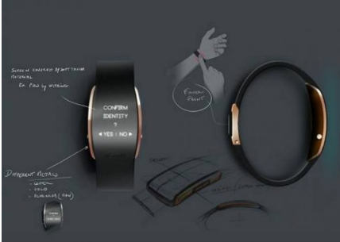

uBolt, an innovative and unique multi-factor authentication personal identity wearable device combining biometric fingerprint and voice recordings and a secure element to ensure “you are who your say you are” to establish trust and verifiable confidence in a user identity.

COMPUTER PERIPHERALS

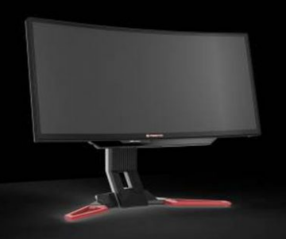

Predator Z301CT monitor

Acer

The Acer Predator Z301CT is the world’s first 21:9 curved monitor with eye-tracking functionality.

HOME APPLIANCES

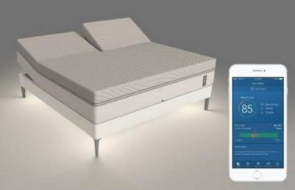

Sleep Number

Sleep Number’s 360 smart bed will forever transform the way people sleep. The new integrated design includes a proprietary algorithm (powered by SleepIQ technology) and machine learning to intuitively sense and automatically adjust all night for an effortless and optimized sleep experience.

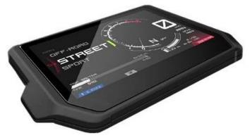

Integrated Connectivity Cluster

Bosch

The ICC is the all-in-one information and communication system for motorcycles – and riders. It is the first of its kind integrating head-unit functionality into a cluster. The HMI clearly displays nothing more (and nothing less) than the information essential to riders looking to take their experience to the next level.

TECH FOR A BETTER WORLD

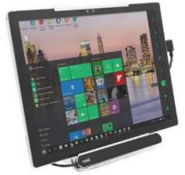

Tobii Dynavox PCEye Mini with IS4 Eye Tracker

Tobii Dynavox

The Tobii Dynavox PCEye Mini featuring IS4 eye tracker is the world’s smallest and most robust eye tracker. Optimized for individuals that do not have use of their hands due to various disabilities, the device enables users to control a computer, laptop or tablet using only their eyes.

SMART HOME
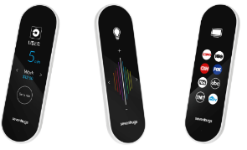

Smart Remote by Sevenhugs

Smart Remote is the world’s first contextual control system for connected homes. It lets you control everything at home with just one touch. When you point Smart Remote at a device, the screen automatically adapts and you just need one touch to control it. A seamless and intuitive control system.

That’s it for January, hope your New Year will be a wonderful one for you and yours. Aloha,



Pooky & Lou

